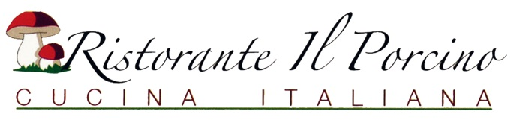
DINNER ANTIPASTI
BRUSCHETTA $16.50 (vegetarian)
Fresh diced tomatoes with garlic, extra virgin olive oil & basil served over toasted Italian bread
MOZZARELLA CAPRESE $18.00 (vegetarian)
Fresh tomatoes, mozzarella & basil with extra virgin olive oil

GRILLED PORTABELLO MUSHROOM $18.00(vegetarian)
Grilled served with gorgonzola cream sauce chopped tomato

CARPACCIO DI MANZO $20.95
Thinly sliced beef fillet marinated with extra virgin olive oil

PROSCIUTTO MELONE $20.95
Fresh cut melon with thin sliced prosciutto, parmesan cheese & balsamic vinaigrette
CALAMARI FRITTI $23.00
Fresh squid, fried and tossed in garlic-lemon spices, served with cocktail sauce
GAMBERI SALTATI $18.50
Pan seared prawns served over arugula
ANTIPASTI ALLE ITALIANA $25.00
Including: prosciutto, Italian salami, caprese, grilled zucchini & eggplant, roasted bell peppers, artichoke & olives
INSALATA e ZUPPA
INSALATA CESARE $13.95
Romaine lettuce, croutons, parmesan cheese tossed with homemade Caesar dressing
INSALATA DELLA CASA $13.95
Organic mixed greens tossed with Italian dressing
INSALATA DI SPINACI $14.95
Fresh spinach with orange, tomato, artichoke & walnuts, tossed with olive oil and vinegar

INSALATA RUCOLA $14.95
Arugula salad with beet, melon, caramelized walnuts, feta cheese, olive oil & balsamic vinegar

ZUPPA MINESTRONE
Classic Italian Vegetable Soup Cup $10.00 Bowl. $14.00
Add to your salad: Grilled Chicken $14.00, Prawns $16.00, Fresh Salmon $19.95
Complimentary Bread service first serving free, After that $5.00 per serving

