

Red’s Table
Private Events Package

PRIVATE EVENTS AT REDS TABLE

If you are seeking a special venue in which to host a business gathering or family occasion, look no further than Reds Table. We offer several, spectacular rooms appropriate for either private parties or corporate events. Our private dining room inside can accommodate anything from an intimate gathering of 8 to large private events of up to 30. Our entire restaurant is available for groups up to 200 and our popular back patio can fit up to 60 people. Red’s Table offers one of the most scenic dining experiences in Reston, Virginia. From weddings to luxurious sit-down dinners, and cocktail receptions, every event at Reds Table is unforgettable.

For Private Dining and Special Event reservations please contact:
Ryan Tracy @ rtracy@mprdev.com

Event Spaces
For a smaller or more private event our Private Dining Room is the best choice and can hold up to 25-30 people for a seated function. For a cocktail function, this space can hold up to 20-25 people comfortably.

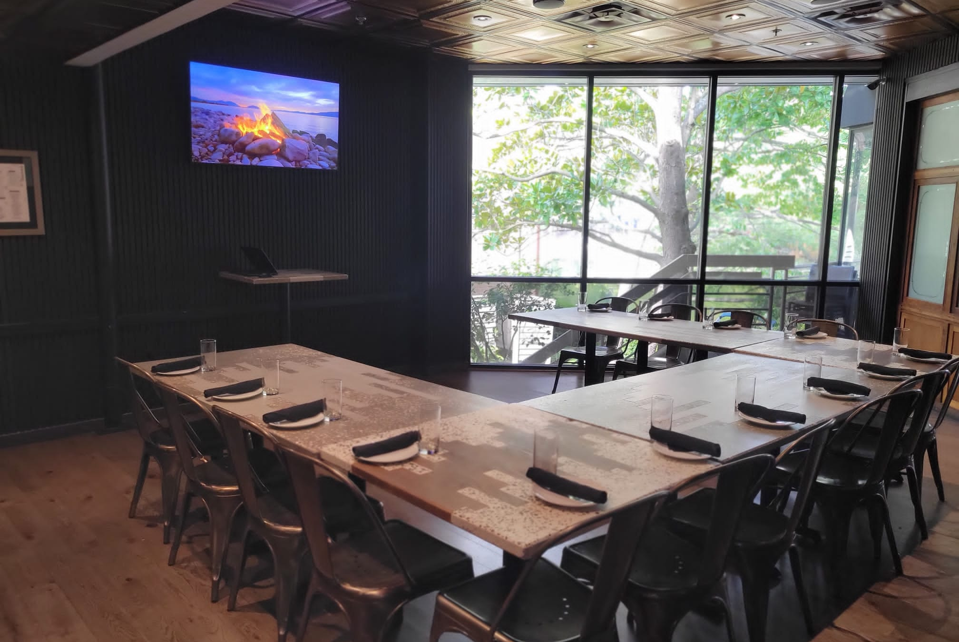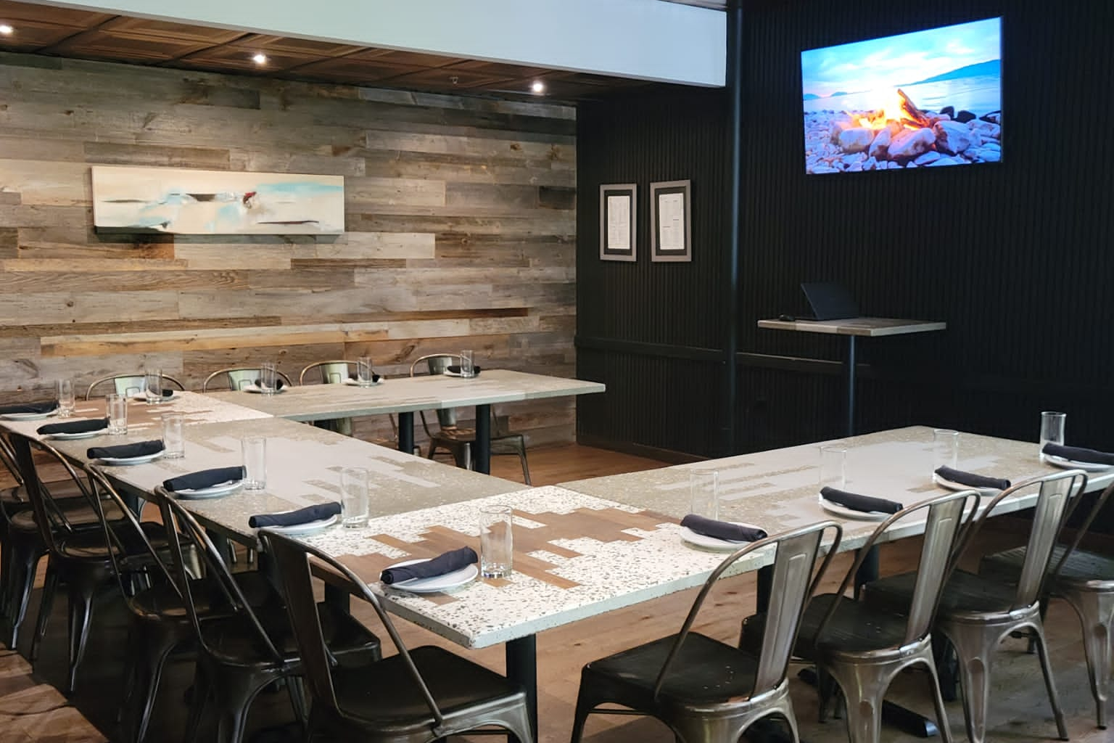
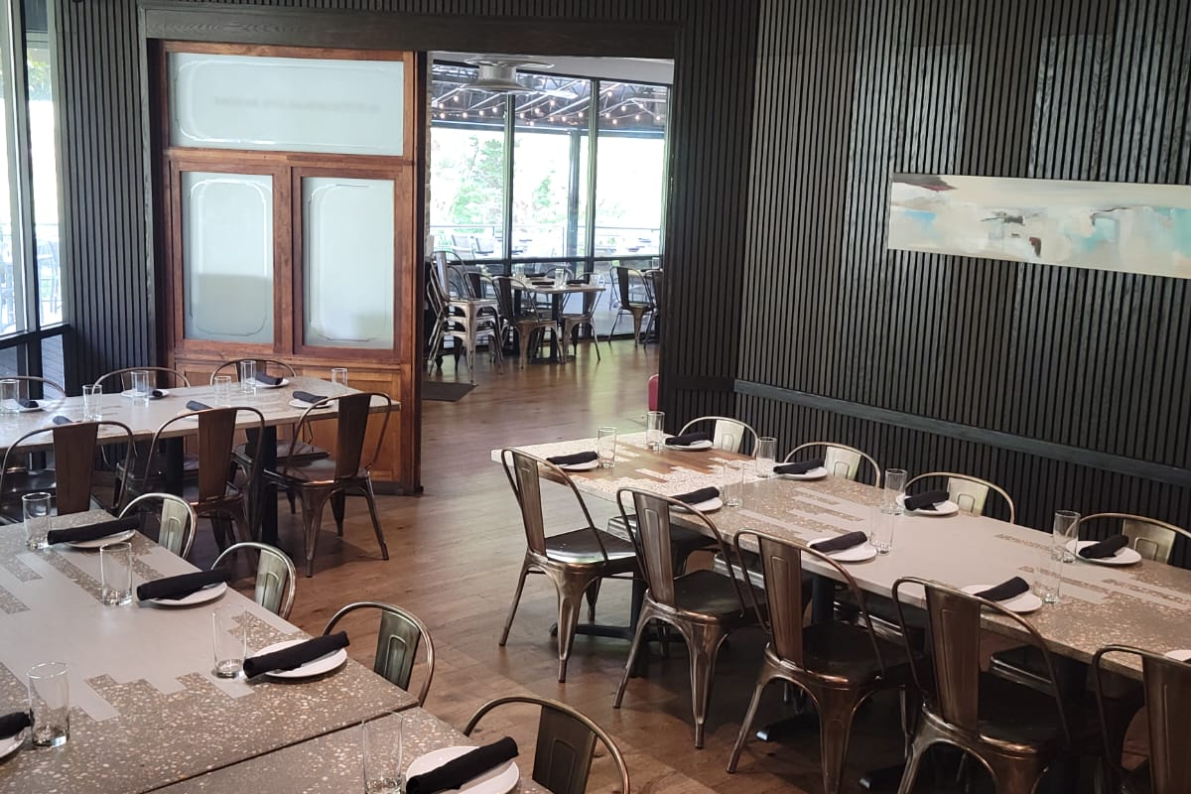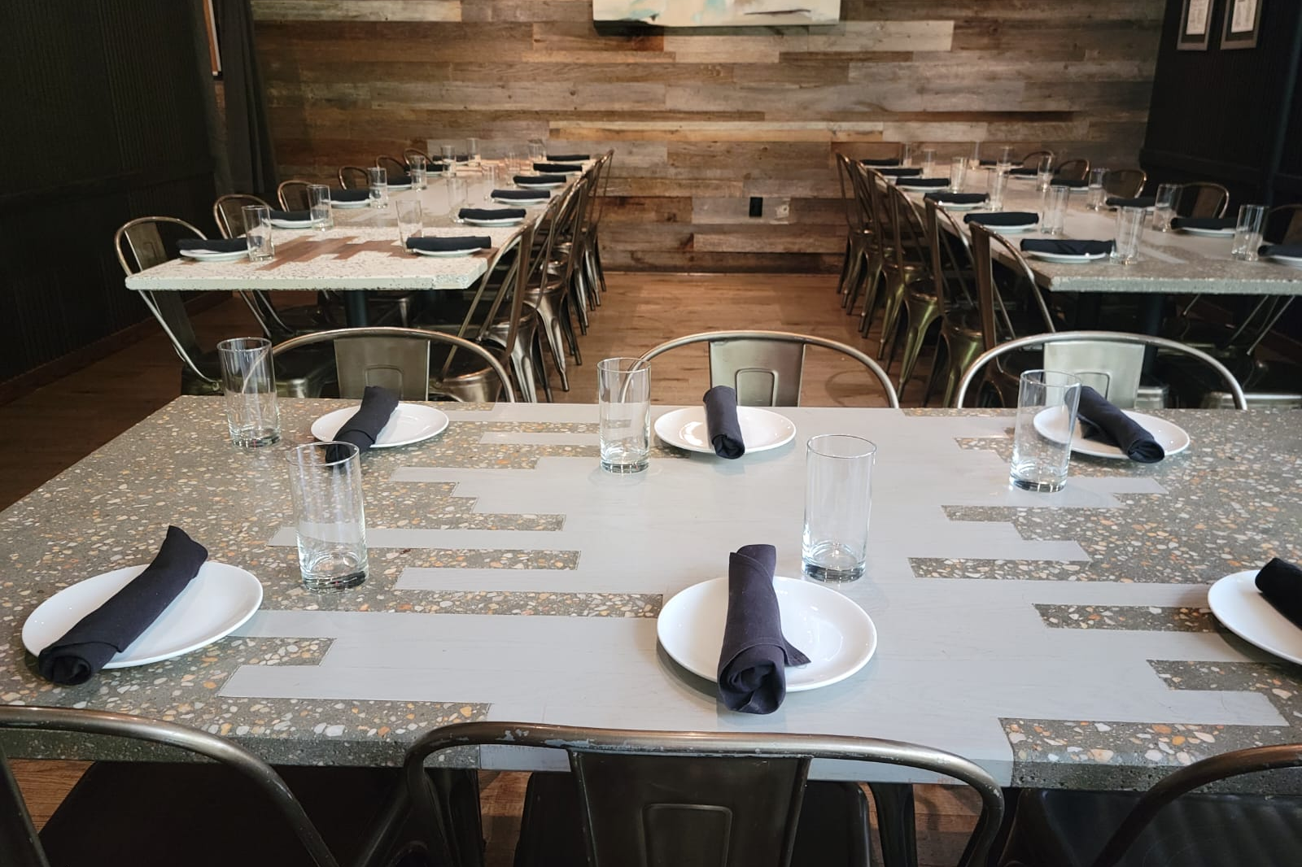

Our back patio is a better option for larger functions and can seat up to 50-55 for a lunch or dinner or up to 60-65 people for a cocktail event.
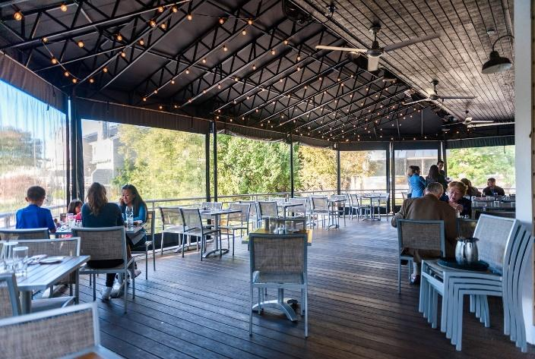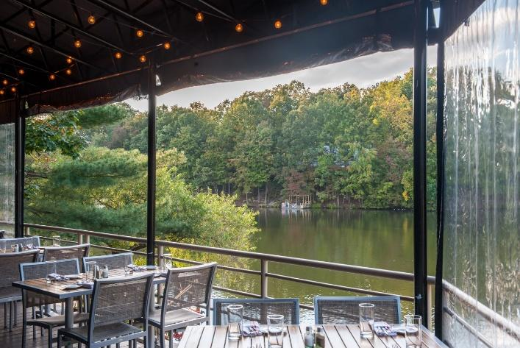
Our front patio is a great option for smaller gatherings & cocktails functions. This space can accommodate 10-20 people.
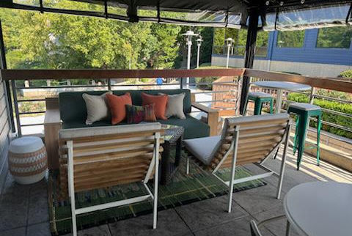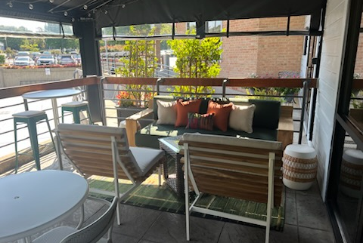

We also offer the option to reserve the entire restaurant for your event if you would like a private event for a large group.




Private Event Menu:
(Buffet/Family Style/Catering)
Appetizer Platters:
- Farmstead Cheese & Charcuterie Platter with Grilled Bread $160
- Vegetable Platter with House Made Ranch and Hummus $140
- 20 Dry Aged Beef Sliders (cheddar, b&b Pickles, caramelized onions) $110
- 20 Trio Meatballs with Pomodoro Sauce, Fontina, & Crostini $120
- 20 Crab Cakes $160
- 20 Goat Cheese Fritters $55
- 30 Oven Roasted Chicken Wings $80
- Shellfish Tower $160 (3 Dozen Shrimp Cocktail & Oysters)
- 2 dz Shrimp Cocktail $48
- 1 dz Chilled lobsters (tails and claws) MKT
- Chilled Alaskan Crab Legs MKT
- 2 dz Oysters on the Half Shell $60
- 2 dz Middleneck Clams on the Half Shell or Steamed $30
- Prince Edward Island Mussels $50
- Point Judith Calamari $60
- Peel and Eat Gulf Shrimp $90
- Sweet Potato Salad: Red Leaf Lettuce, Goat Cheese, Quinoa, Crispy Sweet Potato, Pickled Apple, Apple Vinaigrette $150
A La Carte Entrees: 20-30 Servings
- Pasta with Pomodoro Sauce, Grana Padano and Shredded Basil $75
- Seasonal Vegetable Pasta $70 (add blackened chicken +$40)
- 30 Buttermilk Chicken Strips $90
- 3 Whole Roasted Carved Chickens $120
- 5 Pounds Braised Pork Shoulder with BBQ Sauce $180
  - ( add 40 Slider Buns for $70)
- 15 Pound Whole Sliced Ribeye with Horseradish Cream Sauce $MKT
- Stout Braised Brisket $MKT
- Whole Roasted Side of Salmon with choice of Pesto Cream or Lemon Beurre Blanc Sauce $MKT (Other Fish Available per request)
- Fried Tofu with Sticky Rice (Baby Bok Choy, Pickled Shiitake Mushroom, Sweet Chili Sauce, Tamari Ginger Sauce $250
- Cobb Salad $170
Side Dish Options: $70 per order
(All Sides Serve 10-15 Guests)
- Potato Salad
- House Hand-Cut Fries
- Mac & Cheese
- Pasta Salad
- Buttermilk Mashed Potatoes
- Roasted Potatoes
- Brussel Sprouts
- Roasted Chefs Choice of Vegetables
- Mixed Green Salad
- 30 Biscuits
- 40 Slider Buns
Brunch Options:
(All Brunch Items Serve 10-15 Guests)
- 20 Large Pancakes $80 (Add blueberries or Chocolate Chips $50)
- 60 Small Pancakes $80 (Add blueberries or Chocolate chips $50)
- 10 Waffles $70
- Chicken & Waffles $120
- Quiche Lorraine (bacon, caramelized onions, swiss cheese) $120
- Scrambled Eggs $70
- Bacon $70
- Sausage $70
- Home Fries $70
- Berries & Cream $70
- 30 Biscuits $70

Dessert options:

Cookies and Bars: $36 per dozen.
- Fudge Brownie
- Raspberry Cheesecake Brownie
- Lemon Bar
- Pecan Bar
- Snickerdoodle Blondie
- Chocolate Chip Cookies
- Oatmeal Cookies
- Snickerdoodle Cookies
- Sugar Cookies
Pastries & Savories: $42 per dozen.
- Mini Filled Croissants: (Plain, Almond, Cheese, Chocolate, Raspberry)
- Gourmet Scones: (Plain, Almond, Blueberry, Cranberry,
Chocolate Chip, Raisin)
- Mini Cinnamon or Sticky Buns
- Assorted 5oz Bagels

Cake Options:
10” round (serves 10-12 people) $90
8 x 16 (serves 20-25 people) $120
Cup Cakes (minimum of a dozen) $58 per dozen
Cake Flavors
- Chocolate cake
- Vanilla cake
- Carrot cake
- Lemon cake
- Red Velvet cake
Frosting Options
- Vanilla Buttercream
- Chocolate Buttercream
- Cream Cheese Frosting

Pie Options: (10”, serves 10-12 guests) $60
- Apple Pie
- Blueberry Pie
- Peach Pie
- Banana Cream Pie
- Lemon Meringue Pie
- Chocolate Pie
- Sweet Potato Pie

Red’s Table also offers Two & Three Course Menus for Groups ranging from
10-30 Guests.

There is No Fixed Price.

*Groups with 20-30 guests will be required to pre order their items ahead of the event.

The Host of the Event Can Choose 3 Appetizers & 3 Entrees for a Two Course Menu. Or 3 Appetizers, 3 Entrees, & 2 Desserts for a Three Course Menu.

All Items ordered will be charged the regular menu price.

The Menu can be personalized & the prices can be removed.

*Groups of 30 or more will be required to order off the private events menu. The private events menu can be served buffet or family style.

